
Build the Framework for Small Business Success
ResultsResourcing
connects solopreneurs
with top-tier freelance
talent through
personalized support.

Get matched with
qualified, experienced,
US/Canadian freelance
virtual assistants and
teams with expertise
across various key
business roles.

Fast, easy, and
guaranteed
satisfaction.
About Us
MAXIMIZE
YOUR
IMPACT

Presented By:

Elizabeth Eiss, Founder and CEO of ResultsResourcing
This handout is designed to guide you through key topics discussed in the webinar and help you identify actionable insights you can implement now to strengthen your business in 2026.
Access the full webinar replay: https://bit.ly/4aiKXdX

Delegation Engine™ Framework
Think Bigger about your role as CEO and Founder
Understand the value of your time
Apply an AI + human hybrid model
Follow the P>T>P method (Process>Tools>People)
Harness the power of ‘Virtual Assistance’

Embrace Your CEO Role
What gets in YOUR way of your business success?
What is one thing you can do to lead more (and work less)?

What is one thing you can stop or change to make space for this?


Understand the Value of Your Time
- How much is an hour of your time worth? ____________
- How many hours do you work each week? ____________
Multiply 1 X 2 = _________
That’s the value of your time in a week. Are you investing or spending it?
Try the ROI of Time Calculator to gain clarity on your core vs. non-core work.
List 3 tasks below that fall below your hourly value.

Do Core Work (vs Non-Core Work)
Front Office (e.g., strategy, client delivery, partnerships): What core work do you do? Consider work that delivers value to your clients/customers - what they pay you for.
Back Office (e.g., admin, CRM updates, social execution): What non-core work do you do? Consider tasks that support your business but do not drive meaningful value.
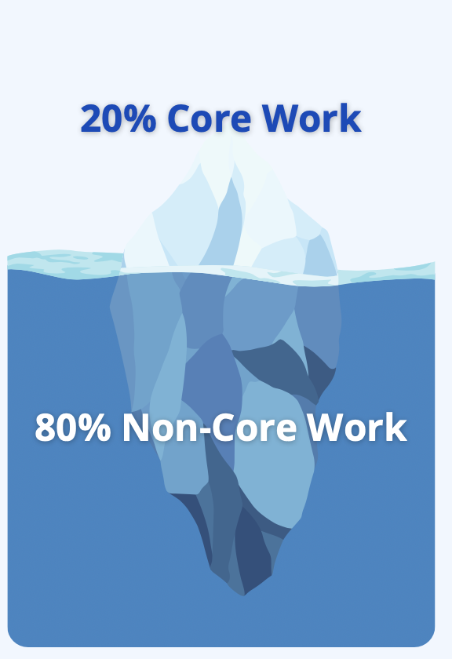
What would you outsource now if you had the right resources?≈




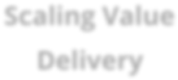
Develop Outsourcing Strategies & Skills
Process
People
Tools
Scaling Value
Delivery
Process: What are your top 5 processes for delivering value to your clients/customers? Are the processes documented in some way?
Tools: What tech/digital tools do you use to streamline processes?
The Delegation Engine™
People: Who supports judgment, creativity, or execution today?





Do you see opportunities to strengthen or improve any of these areas?
Availability
Skills
Flexibility
Freelancers

Harness the Power of Virtual Assistance
What are 5 things you’d consider outsourcing to a competent, reliable, and nice freelancer (or team) that would free you up to do more of what matters?
*Star the ONE task that would give you the biggest time or energy return in the next 30 days.
Book a Free 30-Minute Jumpstart Call

We hope this worksheet helped you clarify where you can build a stronger framework for 2026.
If you’d like support turning these insights into action, book a no-obligation call. Get your questions answers, define your needs, or find support with next steps. Scan the QR code to book.

